ROTARY CLUB PUBLIC IMAGE GUIDE
The purpose of this document is outline guidelines for Rotary Club of <Name> communications, including social media. Social media is an extension of our club online so it is part of our communications toolkit, along with email, newsletters, and your website. A social media plan will help you determine what you want to achieve, which social media platforms are right for your club, and what you want to communicate to our online community. This document is intended to be evergreen. It shall be reviewed periodically to ensure it is current.
PUBLIC IMAGE CHAIR
The Public Image Chair helps the local club tell their clubs Rotary story in a compelling way and guide them in their marketing, media outreach, and social media. The Chair is a contact for the District Public Image Committee to share the district and regionalize Rotary’s public image campaigns. Share with club leaders how to use Rotary’s online public image resources to increase brand awareness.
ROLE OF A CLUB PUBLIC IMAGE COMMITTEE
Our Public Image Committee endeavors to help Grand Island and the surrounding communities understand what Rotary does and how we’re making a difference. The committee promotes Rotary to the public and fosters understanding, appreciation, and support for our programs.
Among other activities this committee's role is to:
- Contact media with stories of projects and events in the district, and share these stories through social media.
- Promote our club’s areas of focus, project successes, and meeting / event opportunities.
- Make public relations outreach a priority through social media.
- Plan and carry out regular postings to the club’s social media outlets in consultation with the President.
- Produce a twice monthly newsletter to members of current events and opportunities including registration for events where we need accurate counts of attendance or sign up.
- Sustain the club platforms and secure from misuse.

Active Accounts
- Website – https://...../ [ClubRunner]
  - Website management
  - Club & membership management (President or Secretary manages adds, updates, deletes, dues billing)
  - Engagement – Events/Calendar, Email services, Bulletins
- Facebook.com/….
- Twitter - none
- Instagram.com/….
- Youtube.com - none
- LinkedIn – none - encourage members to repost to their LinkedIn profiles
- Google - ....@gmail.com
  - My Drive

Social Media Voice
Rotary’s Voice and Visual Identity Guidelines provides essential information to help the public image committee build Rotary’s brand. You’ll learn about our voice and People of Action messaging as well as how to format our logo, choose the correct color palette, and so much more.
VOICE
Our voice — the unique tone and style we use to communicate — focuses on four attributes that describe Rotary and our members: persevering, inspiring, compassionate, and smart. These attributes set the tone for how we talk about Rotary. Think of them as Rotary’s personality.
Rotary’s voice is clear, persuasive, and reliable. It’s personal and sincere.
MESSAGING
We want to distinguish Rotary from other organizations and appeal to all of our audiences by using compelling and consistent messages. Describing and showing ourselves as people of action helps define Rotary for those who don’t know us. Our messaging aims to provide a simple, consistent answer to the question, “What is Rotary?”
Together, we take action to create lasting change in our communities and around the world.
This type of messaging creates a personal connection to Rotary and emphasizes not only the difference we make, but how we make it happen.
Rotary members are effective problem-solvers who create solutions that last because we invest in relationships. We know how to mobilize our networks, and we are constantly learning from our experiences as we participate in clubs, volunteer for projects, and manage our careers.
Using our unique voice consistently in all of your messaging will ensure that your communications sound and read unmistakably like Rotary. By doing so, you’ll also let the world know what we do to help create positive change for the people and places that need it most. We are people of action.
HOW TO USE OUR VOICE
Inspire your audience and give them reasons to believe in your message by offering proof. You can do this by including:
- Stories that show your club members and participants as people of action making a difference in your community
- Clear, compelling facts and data that demonstrate how Rotary contributes to solving problems
- Stories about moments when you or fellow members recognized the power of Rotary.
- Descriptions of how members benefited or grew personally or professionally from their Rotary experience.
- Testimonials from community members or partners that articulate the benefits your Rotary or Rotaract club has brought to those you served or reached.
- Notable programs, projects, press coverage, recognition, or partnerships that reinforce Rotary’s credibility.

Goals and Objectives to Promote our Rotary Club (rewrite after discussion)
Focus efforts by identifying the objectives you want your club to achieve through social media and setting goals that will mark your progress. Keep your goals specific and measureable. Increasing fans and followers is a good objective.
- Establish a Club calendar. A draft calendar of coming events for the Public Image Committee is helpful in giving attention to assembling messaging to the members and public audience. This could be on the Google account which the team shares and integrates with their own calendar.
- One Media Release a Month. Tell our club story to our community! Rotarians do great work in their communities and beyond. Make sure people know about it. Engaging our community generates interest and new members!
- One Social Media Post a Week. Social Media platforms are geared to particular audiences. One post a week to Facebook, Instagram, and LinkedIn will get your story to a whole range of demographics in your community. Repost from other sources items which may be of interest to your members that are in line with areas of focus or networking.
- Give your President a Hand. Manage your Club’s technology, from your website to Zoom meetings, to emails to members, to entering goals in Rotary Club Central. Not all Presidents are confident with technology. Not all Presidents have time for this in addition to their multitude of other tasks.
- Connect your Club to the District, the Zone and RI. You can help ensure your club is recognized for the great work you do. You can bring back ideas from other clubs.
facebook.com/RotaryDistrictXXXX
facebook.com/groups/rotaryzonesXXX
facebook.com/rotary
- Share Your Stories. Your PI Committee is your club story-teller. Send your monthly story for publishing in the District Newsletter! Send those stories to PublicImage@dXXXX.org and we will share them on our social media! Don’t hide your light! Let it shine!
- Counter misperceptions. If Rotary or your club ever gets negative publicity in your community, your committee should meet to discuss how to confront the problem. Counter misperceptions with well-directed public relations efforts. For more information, contact Rotary public relations staff.
- Hashtags. Use hashtags about the subject, term, identification. Persona – audience How to use as #hashtag: Try to think of how your audience would search to find you. Avoid using #ALLCAPS always how the clubs are using the hashtags Try to use a maximum of 5 hashtags. Common used #hashtags: #Rotary7090, #TagtheSpirit, #Rotary, #ImagineRotary, #PeopleOfAction, #GrowRotary, #DisasterRelief, #EndPolioNow, #diversity

Club Newsletter
What can make a useful, readable, bulletin for the Club? There are options. Features of ClubRunner, has a template for a ‘professional’ bulletin, plus our club members email addresses in lists, and archiving of them allowed someone who liked to write and had time to prepare them. We have also used a bulleted email format. Frequency has been twice a month or random as needed.
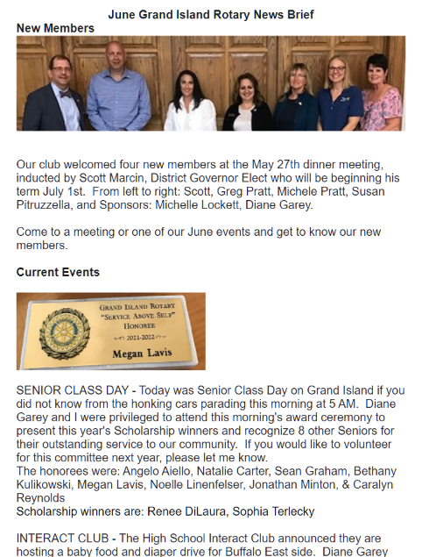
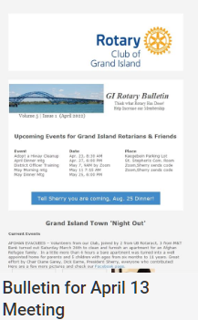

Resources

Email Newsetter from June 3rd

Rotary Areas of Focus
Clubs are advised to focus their service in areas of focus, just be conscious of not spreading themselves too thin. On the other hand, speakers from different areas of focus can add diversity to the program and attract membership. A suggestion is to incorporate the focus logo into Social media images for a speaker that fits with a focus.
Basic Education & Literacy - More than 775 million people over the age of 15 are illiterate. Our goal is to strengthen the capacity of communities to support basic education and literacy, reduce gender disparity in education, and increase adult literacy.

Maternal & Child Health - Nearly 6 million children under the age of five die each year because of malnutrition, poor health care, and inadequate sanitation. We expand access to quality care, so mothers and their children can live and grow stronger.

Peace & Conflict Prevention/Resolution - Rotary encourages conversations to foster understanding within and across cultures. We train adults and young leaders to prevent and mediate conflict and help refugees who have fled dangerous areas.

Disease Prevention & Treatment - We educate and equip communities to stop the spread of life-threatening diseases like polio, HIV/AIDS, and malaria. We improve and expand access to low-cost and free health care in developing areas.

Water, Sanitation & Hygiene - We support local solutions to bring clean water, sanitation, and hygiene to more people every day. We don’t just build wells and walk away. We share our expertise with community leaders and educators to make sure our projects succeed long-term.
Community & Economic Development- We carry out service projects that enhance economic and community development and create opportunities for decent and productive work for young and old. We also strengthen local entrepreneurs and community leaders, particularly women, in impoverished communities.
Support the Environment - Rotary’s newest area of focus is the environment which will enable Rotarians and Rotary Clubs to bring about positive change in the world and increase our impact.

Resources

- Rotary International Brand Center - https://brandcenter.rotary.org/ Get everything you need from Rotary's branded materials, generate logos and customizable materials. Includes the Brand Guide for colors and logo usage.
- Facebook Group – “Rotary Club Members: Public Image, Graphics & Ideas Hub” – large group of Rotary club content creators who share their images and advice.
- Canva – a free licensed web-based graphic software that holds templates for the different communication uses. It is easy to take the color guidance in the Rotary branding and create a custom pallet supporting Rotary approved colors. Fonts have near matches.
- Signup genius – a free licensed web-based registration tool to manage signups for meetings and events. It will integrate with Zoom to send a link if scheduling a zoom call.
- District XXXX Public Image Support -
- ClubRunner Webinars – Register by logging into the member area of our club website – rotaryclubgi.org. Select Help > Webinars choose the focus area you want to learn. ClubRunner technical support is very helpful if you have reviewed the helps and still are stuck. For assistance, call toll free 1-877-469-2582, option 2
- District contractor for Website change assistance is xxxxx (President should contact for now)

VOICE AND MESSAGING, RI Brand Center © 2022 Rotary International

